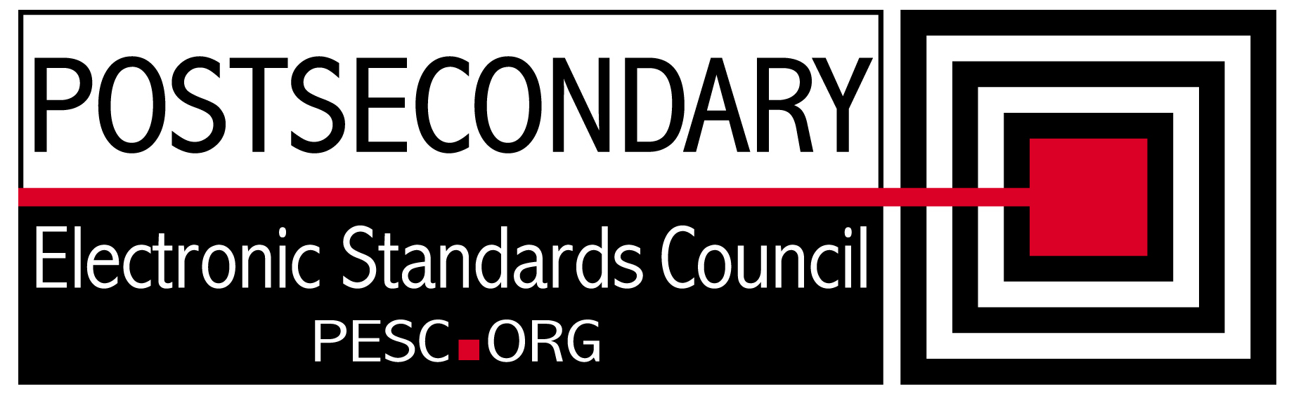

Standards Forum for Education
Status Update Form

Workgroup/Board Group Name | Technical Advisory Board
General Summary of Status | Developing a plan to moving to the NIEM framework for XML Exchange Standards
Status Flag (Red/Yellow/Green) | Green
Report Data | 1/13/2012
Projected Completion Date | Standing PESC Board

Item | Responsible Resource | Status  (Report update status of Deliverable/Objective  since last report)
Planned Deliverables/Objectives
(Provide at least 3)
Component Architecture: Single file schema | Morris/TAB | NIEM provides a subset schema concept that can be used to simplify PESC schemas
NIEM Evaluation | TAB | Worked with Home Land Security to understand ownership of NEIM Domain. FSA agreed to participate with PESC on adhering to NIEM framework
Language Support | Hamidi/ Margenau | On hold pending NIEM discussion. NIEM supports language designation metadata
XML R&R | Morris/Sue Lou (FSA) | Continued providing feedback to FSA on approaches to populating XML R&R with core components
Guideline for XML Architecture and Data Modeling revision | TAB | On hold until NIEM approach is settled.
Accomplishments/
Completions
Issues/Obstacles
Meetings/Calls Since Last Update | 4

Note: Chairs and/or leaders of workgroups, boards and committees under The Standards Forum for Education are required to provide updates during the Steering Committee’s monthly conference call meeting held the second Friday each month at 2:00pm EST. Call in information is: 866-352-3799 *7696363*. Forms must be completed and submitted prior to meeting time. Forms may also be posted on the PESC website as needed to provide the community at-large with a means to obtain updates for ongoing, but yet to-be-completed development efforts.

To add rows to table, click outside of the table, to the right on the row where you want to add another row . With cursor blinking, hit the enter key. A new row will be inserted.

